## Quiz: Refresh and resume

## Quiz Link: [Quiz: Refresh and resume | Watch and Code](https://watchandcode.com/courses/programming-foundations/lectures/22913488)

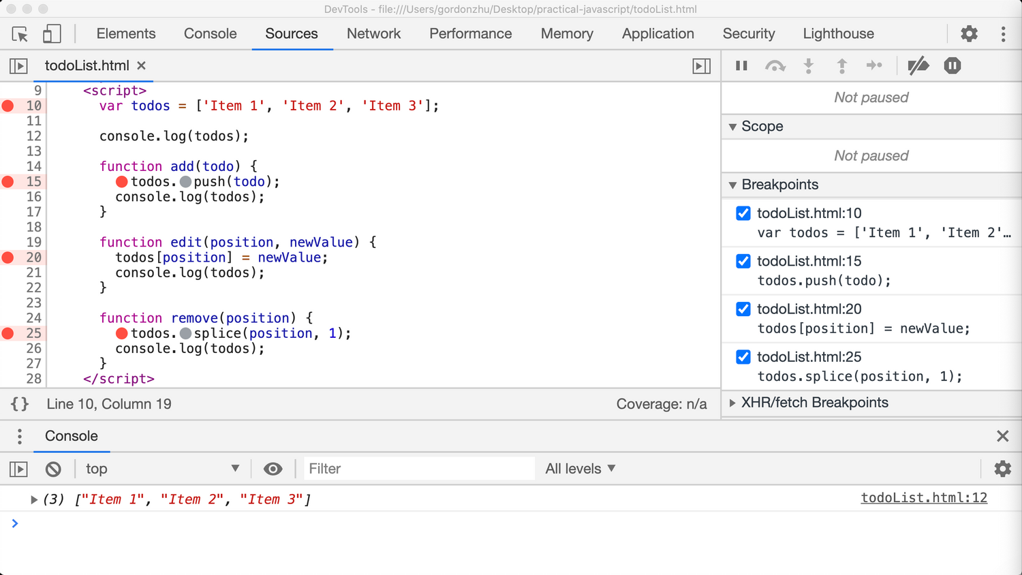

Here's a screenshot of my computer. After hitting refresh and clicking "Resume script execution", which of the following statements will be true?

1. The program will be paused at line 10
   1. FASLE – 100%
   2. Not paused at this line.
2. The program will be paused at line 15
   1. FASLE – 100%
   2. Not paused at this line.
3. The program will be paused at line 20
   1. FASLE – 100%
   2. Not paused at this line.
4. The program will be paused at line 25
   1. FASLE – 100%
   2. Not paused at this line.
5. None of the above
   1. TRUE – 100%
   2. All the above statements are false.